3.Requirements Gathering
The requirements for the FixIt Jo project were collected using questionnaires distributed to potential users and local technicians. This method was selected because it is simple and effective, allowing feedback to be gathered from multiple participants in a short time. The questionnaires focused on common maintenance needs, user expectations, and essential application features. The responses were then analyzed to identify both functional and non-functional requirements of the system.
3.1 Data Collection
To better understand user needs, a questionnaire was designed and distributed to both customers and technicians. The following are sample questions used during the requirements gathering process:
👤 Customer Questions:
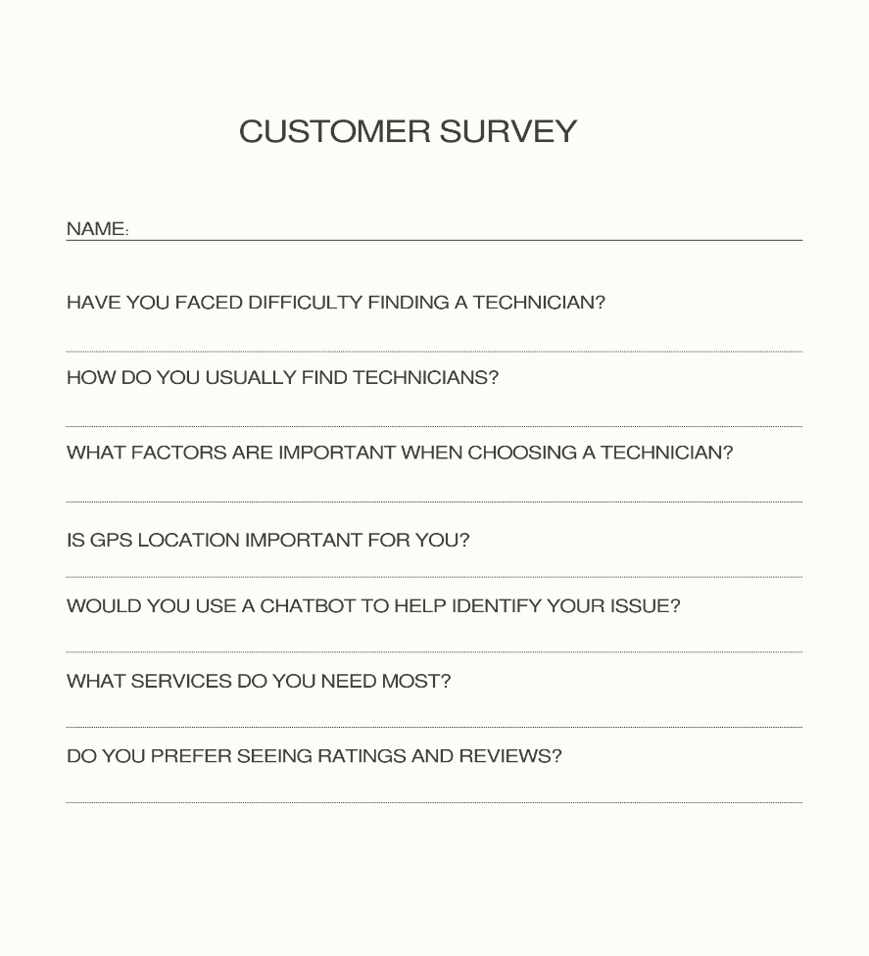
🔧 Technician Questions:
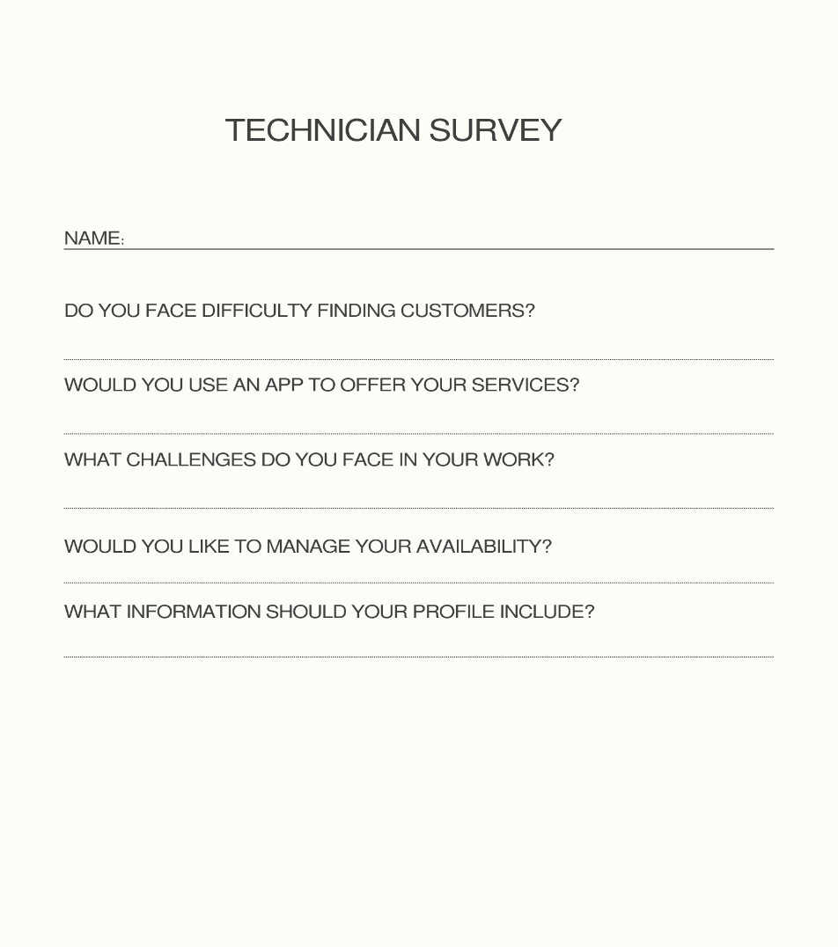

The responses to these questions were analyzed to identify the system requirements, including functional and non-functional requirements.

User Stories
User stories are used to describe system requirements from the user’s perspective.
Customer:
- As a user, I want to create an account so that I can access the system.
- As a user, I want to request a service so that I can solve my problem.
- As a user, I want to find nearby technicians using GPS.
- As a user, I want to communicate with technicians.
- As a user, I want to rate technicians.
Technician:
- As a technician, I want to manage my profile.
- As a technician, I want to receive service requests.
Trello
The requirements were organized using Trello
